**Assignment 2 Power BI**

1. **Explain the advantages of Natural Queries in Power Bi with an example?**

* NLQ is a unique self-service BI experience

provides immediate assistance on the question you want to ask, with no guesswork or technical knowledge required to get started with using the tool.

After selecting a dataset, you’re presented with a search box you can type in, but it’s not blank. Guided NLQ provides a list of options for possible questions, then guides you through each step in formulating the query.

## Every question is understood by Guided NLQ

Traditional search-based NLQ solutions are harder to set up because they’re focused on fixing the wrong problem: semantics (language used in a question), rather than analytics.

With Yellowfin Guided NLQ, there is no need to set up synonyms and word dictionaries, or continuously train the solution to understand your users’ intent, because using the Yellowfin metadata layer bypasses this problem altogether.

## Guided NLQ makes it simple to ask complex questions

The questions you can ask search-based NLQ tools are often too basic because the vendor has spent all their effort in fixing the language problem, and their approach doesn’t support question complexity in the best way.

Guided NLQ approaches question complexity differently by implementing thousands of comprehensively modelled question types and sequences, which effectively enables anyone to ask questions of their data, and to deliver answers as best practice visualizations or tabular reports for every possible question combination you can think.

1. **Explain Web Front End (WFE) cluster from Power BI Service Architecture?**

The **WFE** cluster uses Azure AD to authenticate clients, and provide tokens for subsequent client connections to the Power BI service. Power BI uses the **Azure Traffic Manager** (Traffic Manager) to direct user traffic to the nearest datacenter. Traffic Manager directs requests using the DNS record of the client attempting to connect, authenticate, and to download static content and files. Power BI uses the **Azure Content Delivery Network** (CDN) to efficiently distribute the necessary static content and files to users based on geographical locale.

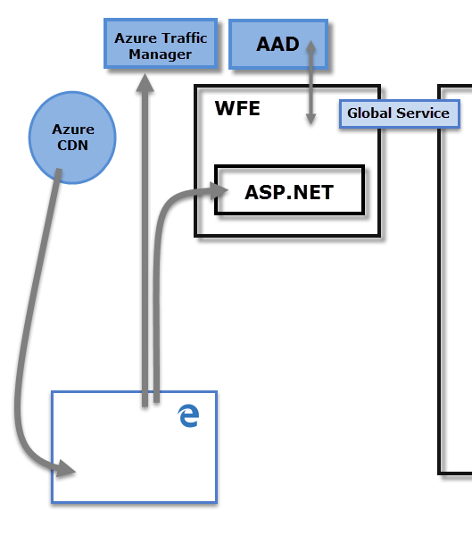

The Web Front End (**WFE**) cluster. The **WFE** cluster manages the initial connection and authentication to the Power BI service.

1. **Explain Back End cluster from Power BI Service Architecture?**

The **Back-End** cluster determines how authenticated clients interact with the Power BI service. The **Back-End** cluster manages visualizations, user dashboards, datasets, reports, data storage, data connections, data refresh, and other aspects of interacting with the Power BI service. The **Gateway Role** acts as a gateway between user requests and the Power BI service. Users don't interact directly with any roles other than the **Gateway Role**. **Azure API Management** eventually handles the **Gateway Role**.

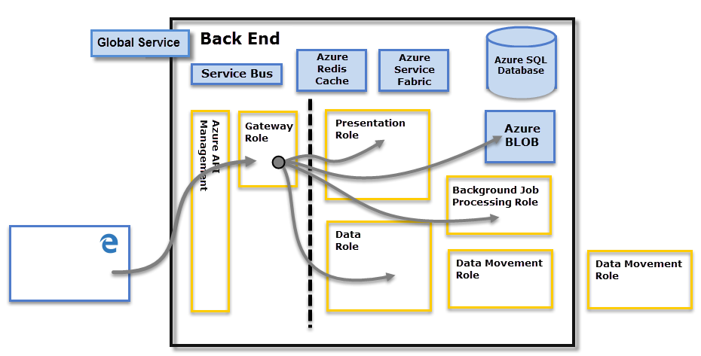

**Back-End** cluster. Once authenticated, the **Back-End** handles all subsequent user interactions. Power BI uses Azure Active Directory (Azure AD) to store and manage user identities. Azure AD also manages data storage and metadata using Azure BLOB and Azure SQL Database, respectively.

1. **What ASP.NET component does in Power BI Service Architecture?**

ASP.NET is a web development platform provided by Microsoft.

* + ASP ==> Active Server Page
  + NET ==> Network Enabled Technologies

ASP.NET component plays a major role while publishing reports and dashboards to workspace where stakeholder interact with it in front end provided by Power BI service. Not only that, BI dashboards can also be accessed through other apps like Microsoft teams which embeds BI Applicaiton through ASP.NET framework

1. Compare Microsoft Excel and Power Bi Desktop on the following features:

Data import

Data transformation

Modeling

Reporting

Server Deployment

Convert Models

Cost

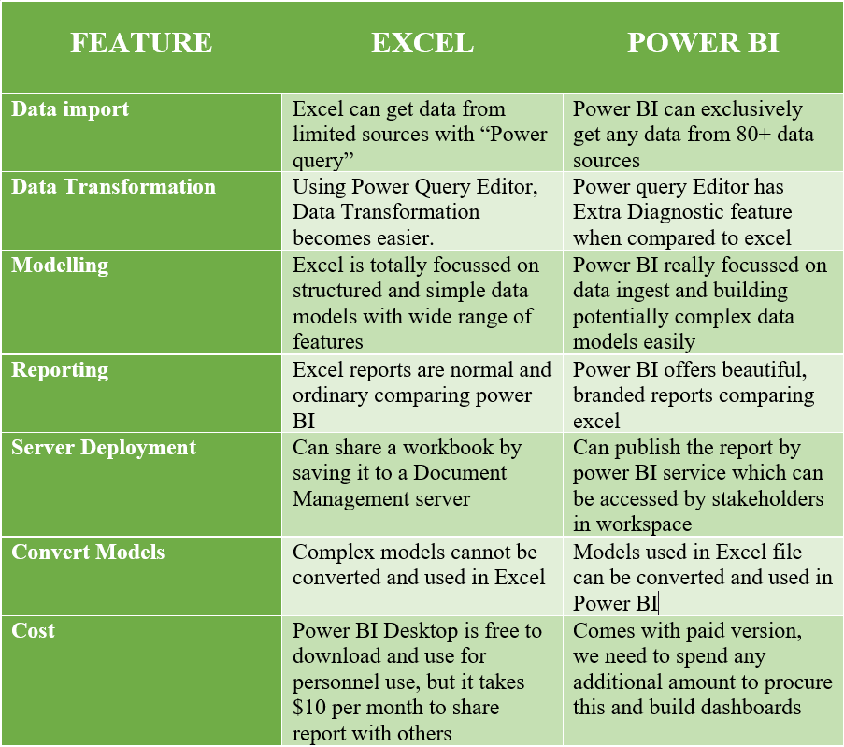

### 6. List 20 data sources supported by Power Bi desktop.

* Access database
* Oracle Database
* IBM Netezza
* Mysql Database
* Postgre Database
* Teradata Database
* Amazon Redshift
* Impala
* Google Bin query
* Vertica
* Snowflake
* Essbake
* Azure SQL Database
* Sharepoint Online list
* Microsoft Exchange online
* Dynamics 365(online)
* Adobe Analytics
* Github(beta)
* Linkedin Sales Navigator(Beta)
* Twilio(beta